CALPRO
Gen 5 Data Sheet

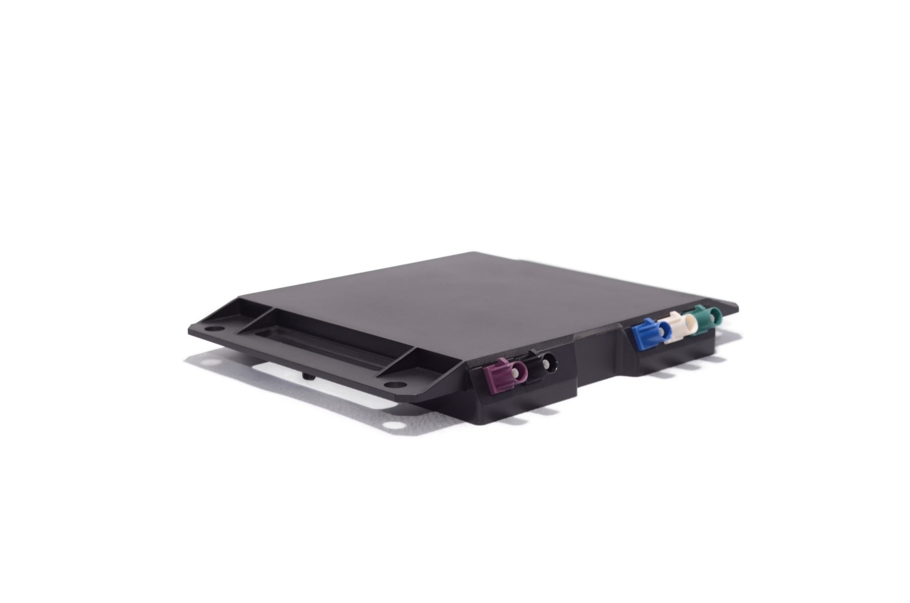
Introduction
The multifunctional CALPRO Antenna sets a new standard for combination antennas. A true breakthrough in form and functional integration, CALPRO combines up to 10 antenna functions, commonly required for the connected car with the benefit of being conformal, completely hidden beneath the roof of the vehicle. CALPRO Gen 5 can be configured to support either 2X2 or 4X4 MIMO modes outperforming all conventional antennas available today. The CALPRO antenna is a broadband array covering functions requiring frequencies ranging from 600 MHz to 6.0GHz.
CALPRO Gen 5 supports 2X2 or 4X4 MIMO capability in both the 4G LTE and 5G NR bands at 617-960, 1710-2170, 2300-2700, 3300-4200 and 4400-5000 MHz. CALPRO’s directionality and strong beam isolation combine to deliver superior performance. This major contribution to the link budget delivers the increased range, high probability of reception, extreme throughput and low latency required to enable assured safety services and rich real time data.

Frequencies and Supported modes
4G LTE Cellular (MIMO 2x2 or 4X4): 617-960, 1710-2170, 2300-2700, 3400-3800 MHz
5G (sub-6) Cellular (MIMO 2x2 or 4X4): 617-5000 MHz
GNSS: 1164-1260, 1559-1610, 1151-1214 MHz, Tri-band (L1,L2 L5) Global Navigational Satellite System (GNSS) for GPS, Galileo, GLONASS, and BeiDou
WiFi/BT (2x2 MIMO): 2400-2484, 4850-5825 MHz
V2X: 5850-5925 MHz, C-V2X or 802.11p/DSRC

Optional Mode
Satellite Digital Audio Radio Service (SDARS) 2320-2345 MHz

Mechanical
Enclosure material/Color: Hi Temp Polycarbonate/Black
Body Dimensions (L x W x H): 158.75mm x 158.75mm x 20mm
Weight: 0.14 Kg
Ingress Protection: To OEMs requirements
Mounting: Flange mounting
Flange Mounting Hole: 5.25 mm

Environmental
Operating temperature range -40˚C to 105˚C
Storage Temperature range -40˚C to 105˚C
Relative Humidity MIL-STD-810G method 507.4 @ 30˚

Outline Drawing

Bottom View | Side View
 | 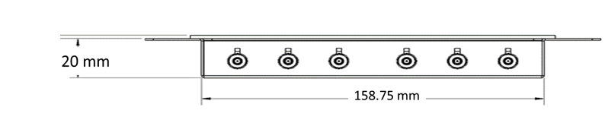

Orientation/Installation
The antenna transmits and receives on all frequencies from the top side of the antenna (radome). When installed in the vehicle, the flange and connectors are in the interior of the car and the black colored top of the antenna is flush with the exterior surface of the car and can be painted to match the vehicle. For optimum performance CALPRO can be installed either under the roof, in the rear spoiler, under a glass or panoramic roof within or close to the A, B or C headers or in the rearview mirror module under the windshield. NOTE: All unused ports must have an external 50Ω termination installed.

ISAM ready
CALPRO Gen 5 has been designed that it can be easily integrated into the same circuit board as the Telematics Control Unit (TCU) in order to create a complete conformal, hidden Integrated Smart Antenna Module (ISAM). In so doing eradicating up to 40 connectors and all their associated coaxial cables, RF loss and installation costs, whilst improving performance and delivering a superior user experience to your customers.

Connectors
FARKA Keyed Connectors
Label | Impedance | Center Conductor  Power
LTE1 | 50Ω | -
LTE2 | 50Ω
LTE3 | 50Ω
LTE4 | 50Ω
WIFI1 | 50Ω
WIFI2 | 50Ω
GNSS | 50Ω | 3.3-5V, 30-40mA
SDARS | 50Ω | 3.3-5V, 30-40mA
V2X1 | 50Ω
V2V2 | 50Ω

